Science Test: Trees and Forest Interactive Study Guide/Review

Useful Links:
http://www.ecokids.ca/pub/eco_info/topics/forests/index.cfm

What is a forest?
What is an ecosystem?

The Importance of Forests
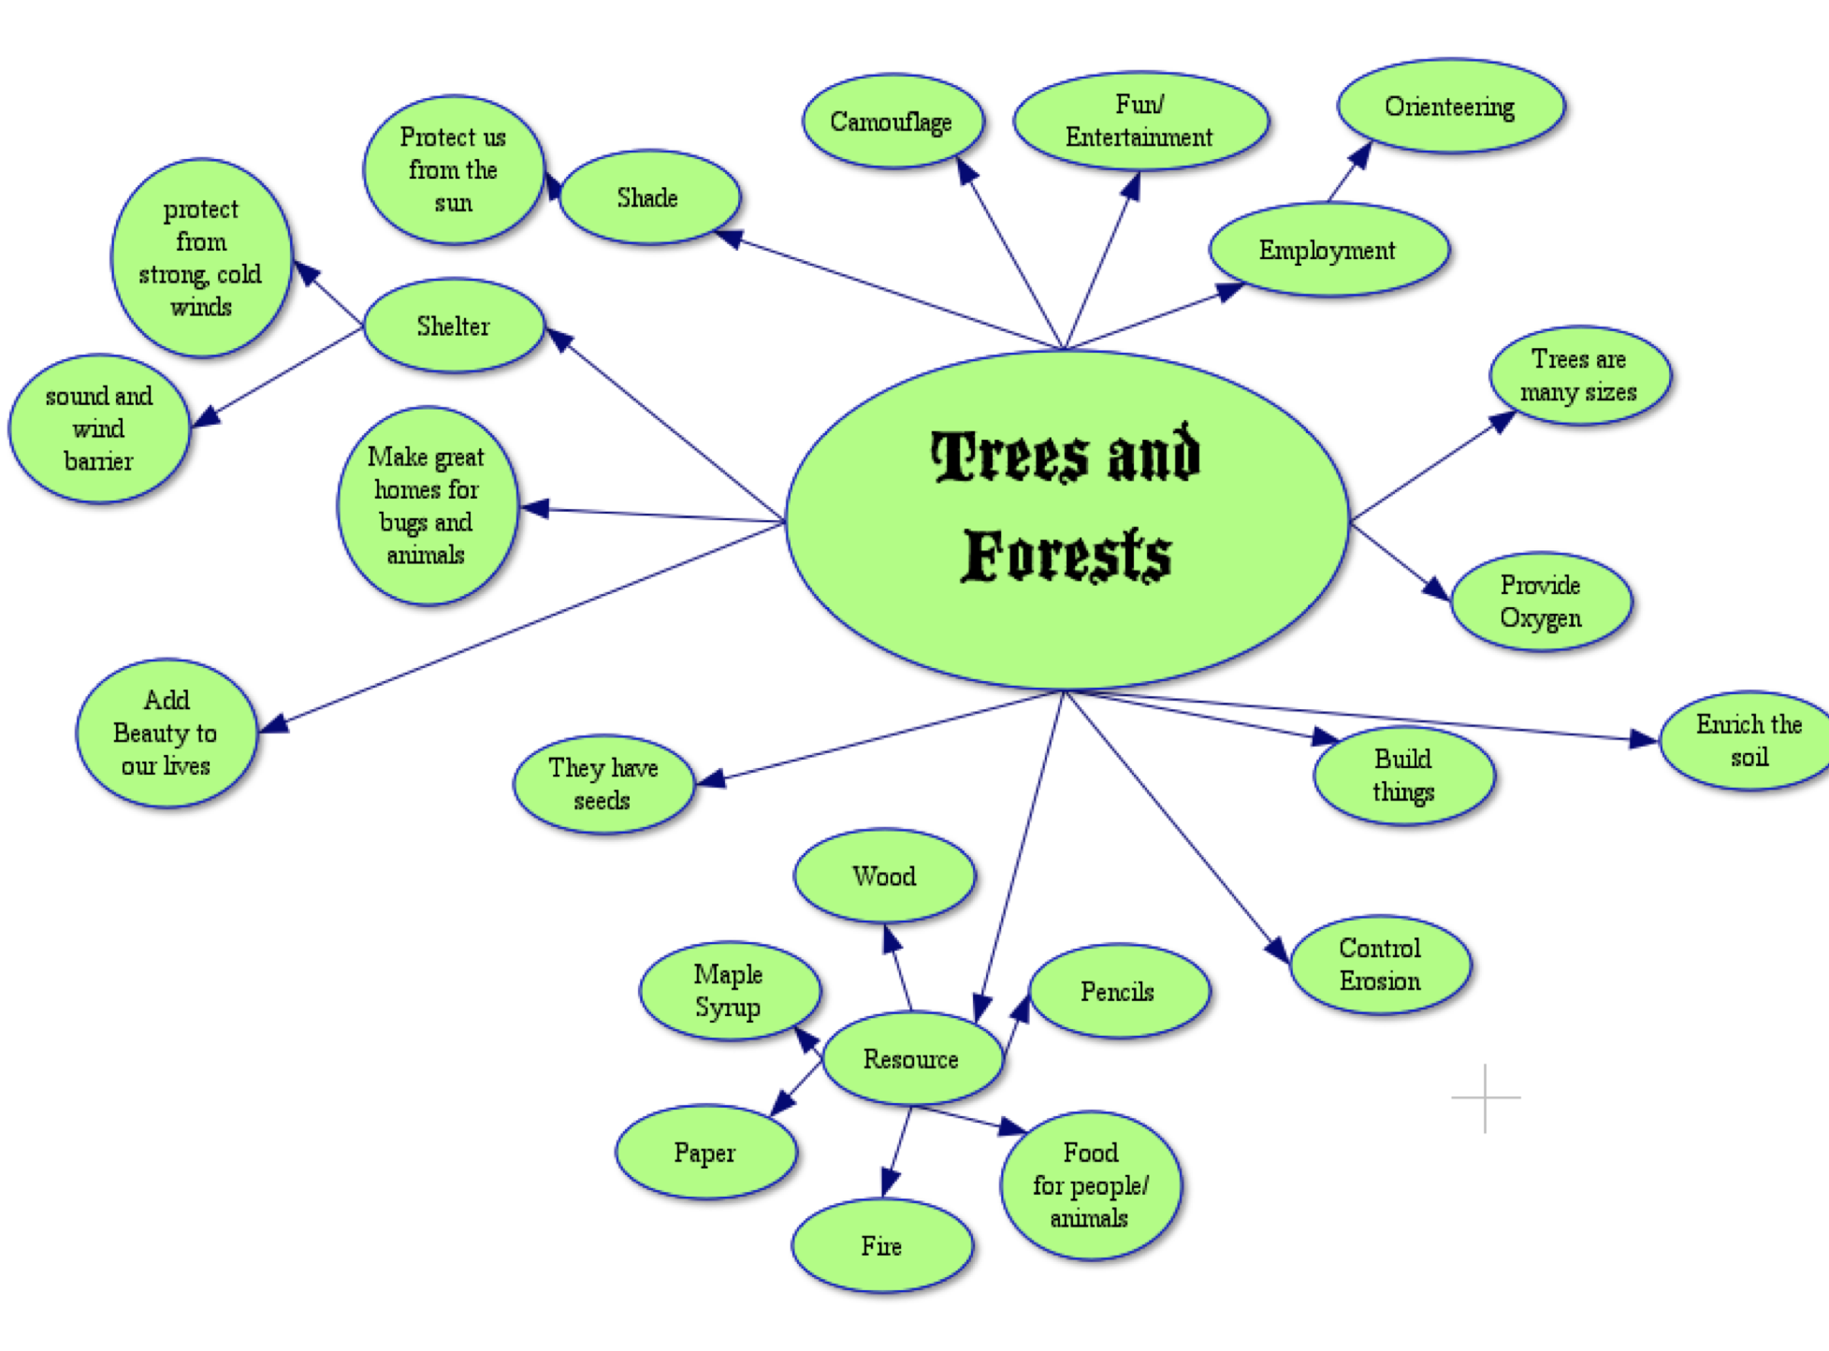
- http://wwf.panda.org/about_our_earth/about_forests/importance/
- https://cfs.nrcan.gc.ca/videos/7 (wood products)
- http://treecanada.ca/en/resources/benefits-trees/

Careers In Forestry:
http://www.goforestry.ca

TREES AND FORESTS

Ecosystem: a community of living and non-living components in relationship with each other and their environment.
Ecosystem Video http://www.neok12.com/php/watch.php?v=zX7d0b756f7154415351047f&t=Ecosystems

PRODUCERS – Producers are green plants (plants which contain chlorophyll). These plants use energy from the sun, nutrients from the soil, and water to make food for themselves and for other organisms.

CONSUMERS – Consumers are organisms that need the food made by producers. All animals are consumers because they eat plants or they eat animals that eat plants.

DECOMPOSERS – These are the living things such as fungi or bacteria that break down dead organisms (plants or animals), and release the nutrients into the soil where they are available to be used by producers.
Games:
http://www.sheppardsoftware.com/content/animals/kidscorner/games/producersconsumersgame.htm
■ Biotic: living components of the environment. (plants, fungus, animals, bacteria)
■ Abiotic: non-living components of the environment. (rocks, water, air, soil, dead organisms)

LAYERS OF THE FOREST:

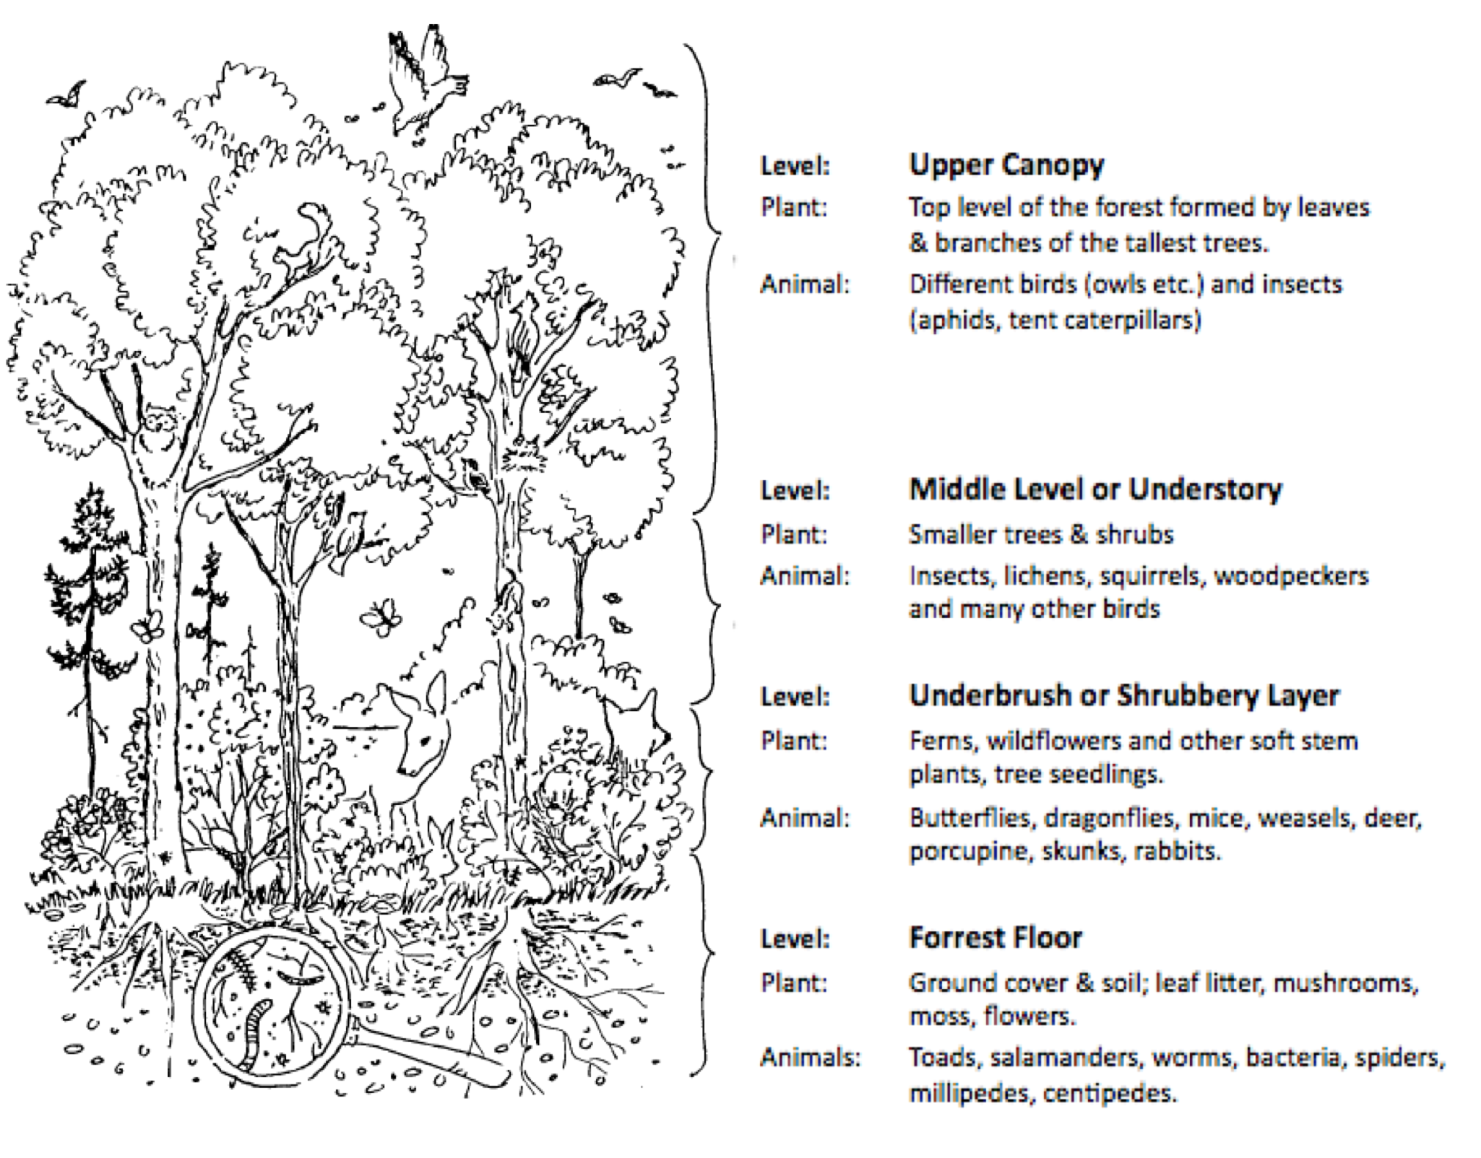

About the layers:

http://www.arborday.org/treeGuide/forests.cfm

What is a food chain and how does it work?

FOOD CHAIN: A food chain is a model that shows how energy is passed, in the form of food, from one organism to another. The arrows between the organisms show the direction of energy flow.
Example=Acorn Bush➔Squirrel➔Owl
• The acorn bush uses energy from the sun to create its own food. This makes it a producer and it is the first level of this food chain.
• The squirrel eats the acorns from the acorn bush. This makes it a consumer because it consumes/eats other organisms for its food.
• The owl is also a consumer because it also consumes other organisms for food. The owl eats the squirrel.
Food Chains:
http://projects.cbe.ab.ca/chinookpark/curriculum_links/Grade_Pages/grade6/Gr_6_Units/science/foodchains/food_chain.html

Decomposer
2nd consumer: Eats a 1st level consumer
1st consumer: They can’t make their own food, so they consume plants and animals. 3 levels:
1-Herbivore
2-Carnivore
3-Omnivore
Producers: Plants, because they produce their own food

Fungi & bacteria: They break down dead material and turn them into nutrients for the soil

Trees:

A tree is defined according to the following criteria:
■ It must be perennial
■ It must have a self supporting trunk
■ The trunk must be made of woody material

A tree is a perennial plant. This means that it survives and puts forth new growth each year. An annual plant is a plant that grows from a seed, survives for one season to produce new seeds, and then dies.
Trees can be classifies into two groups according to whether they lose their leaves every year. These are Deciduous and Coniferous.
- Deciduous Trees - These trees lose their leaves in the fall.

e.g. – Poplar, Birch, Apple, Elm.
These trees are also known in the lumber industry as hardwood trees.

2. Coniferous Trees - These trees (also called evergreens) do not lose their leaves in the fall. They keep their needles all year round.
e.g. – Pine, Fir, Spruce.
These trees are known as softwood trees.

Video on the 2 types:
http://www.youtube.com/watch?v=-lc3vLCKdmg

Trees and the water cycle:
**Forests serve in the water cycle in two critical ways: transpiration and water storage.
**Transpiration= movement of liquid water from plant roots, upward in vessels, and into the atmosphere from the leaves as water vapor.

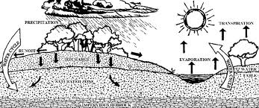

Water Cycle Video:

http://studyjams.scholastic.com/studyjams/jams/science/ecosystems/water-cycle.htm

What is Photosynthesis?
-  Carbon dioxide + water +chlorophyll + sun= sugar + oxygen
-  Trees take in carbon dioxide and water and combine them to make sugars and starches. To make sugars and starches, the tree requires energy which the plant gets by trapping solar energy (from the sun) in the green pigment called chlorophyll.
-  This energy is then used in photosynthesis and becomes trapped in the sugar molecules.
-  Chlorophyll is used over and over again to trap light energy for making food.
- ***The process by which trees make sugars is called photosynthesis.
- See photosynthesis in action: http://www.space.com/22111-satellites-capture-photosynthesis-in-action-video.html
- 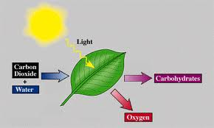
- Wonderville Game: http://www.wonderville.ca/asset/photosynthesis
- The Nutrient Cycle:
Nutrient Cycle
- Decomposers break down the dead matter from trees or animals break down plant leaves
- Nutrients are released back into the soil
- Roots of trees absorb the nutrients
- Nutrients travel up the trunk of the tree and are used as energy for growth.
- Consumers eat the leaves of trees or the dead leaves fall back to the ground

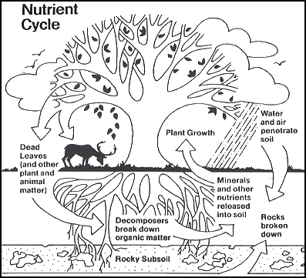

- Parts of a Tree
http://www.canadianforestry.com/html/forest/tree_parts_e.html

- Roots – The root system is the part of the tree below the surface of the ground. The roots absorb water and nutrients from the soil. Roots also hold the tree securely in place in the ground.

- Trunk – The trunk holds the leaves in position to receive sunlight. The trunk is covered with bark. From the trunk and branches of trees we are able to get wood for building things and pulp for making paper products. Trees are an important renewable resource.

- Leaves – Leaves are usually green because they contain chlorophyll. Through the process of photosynthesis, green plants use energy from the sun, carbon dioxide from the air, and water and nutrients carried up from the soil to produce food.
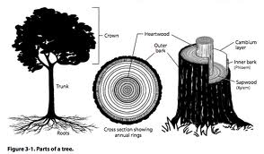

BARK
Bark= the visible outer covering of a tree which protects the inside, as a tree grows, the inner layers cause the outer layers to crack/split, there is always new bark being produced.

Why is bark important?
- To protect the inside
- To protect from invasion by weather, disease, insects
- There are holes in the bark which allow the tree to take in oxygen from the air

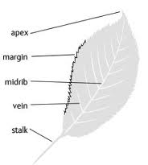
Diagram of a leaf:

Classifying Leaves:

Type:
Simple–=one leaf on each petiole. Compound=more than one blade on each petiole. Double compound= several blades attached to several

Arrangement:
Opposite, alternate, whorle and basal.
Shape: What the shape looks like.(oval, heart, oblong etc.)

Margins: What do the edges of the leaf look like? Smooth, wavy, course tooth, fine tooth.

Tree Cookies:
-Interpret the growth of a young tree, examine each year’s growth, and locate scars that separate old and new growth.
Tree rings (annual rings)
Close tree rings – poor growing conditions
Far tree rings – good growing conditions.
Trees form new wood in the spring and summer
Springwood is lighter than summerwood
Growth of rings is affected by
Weather, amound of growing space, soil condition, insect attacks, fire.

Wonderville Tree Game:
http://www.learnalberta.ca/content/wontg/html/index.html

What are some threats to our forests and how can we manage our forest so that they will be around forever?

(logging, insects, pesticides, roads, pollution, overuse, clear cutting, fire, natural threats like weather etc.)

Info:
http://wayback.archive-it.org/2217/20101208162548/http://www.abheritage.ca/abresources/inventory/resources_forests_change.html

Videos (reforestation, fire, urban factors, sustainable logging)
http://www.natureworkseverywhere.org/video-tour

Clear Cutting vs. Selective Cutting:
http://www.authorstream.com/Presentation/dantescience-267994-forestry-clear-cutting-vs-selective-cut-deforestation-soil-erosion-education-ppt-powerpoint/

*****Another great site to review all concepts:
http://projects.cbe.ab.ca/chinookpark/curriculum_links/Grade_Pages/grade6/Gr_6_Units/science/trees/tree_notes.html

